1. **Config Power BI Report Server**
2. Open Report Server Configuration Manager.
3. If prompted, select Yes.
4. Keep all the option as it is and select Connect.

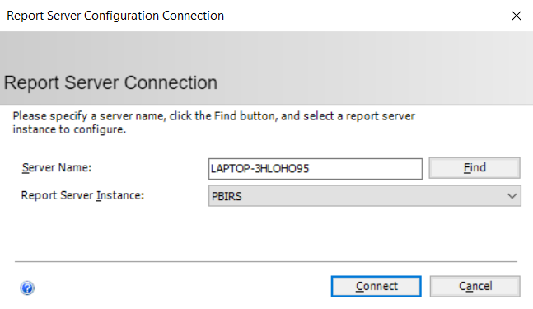

Note: Server Name will vary for each user, don’t change it to match the one in the picture.

1. Select Web Service URL, modify Virtual Directory to ReportServer_PBI and select Apply.

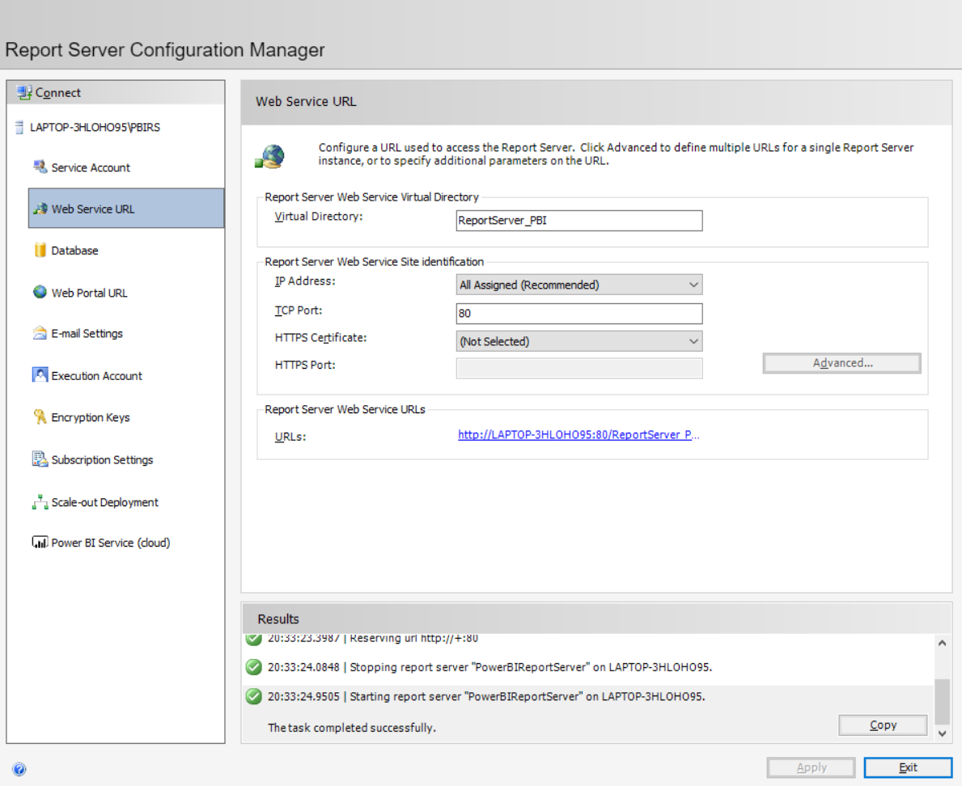

1. Select Web Portal URL, modify Virtual Directory to Reports_PBI and select Apply.

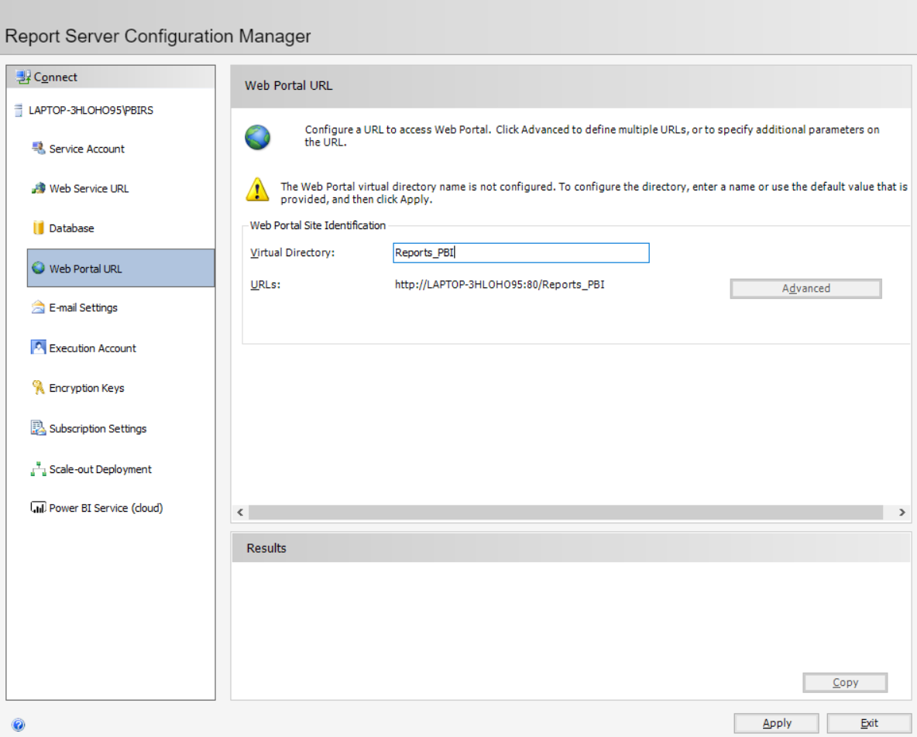

1. Select Database, click Change Database.

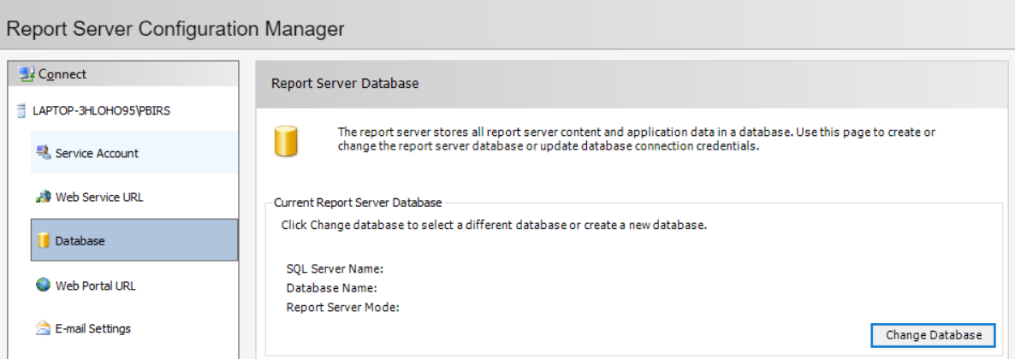

1. Select Create a new report server database, click Next.

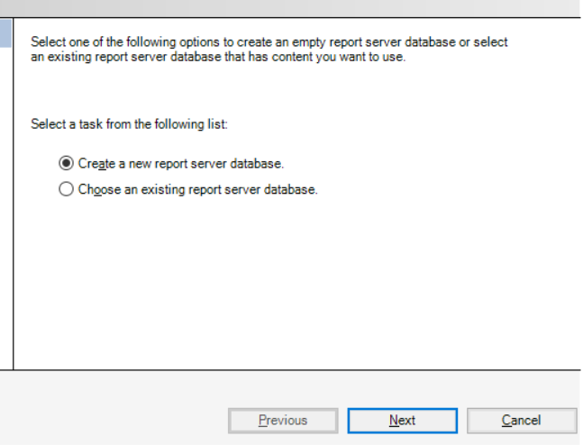

1. Change the Server Name to localhost\sqlexpress and select Next.

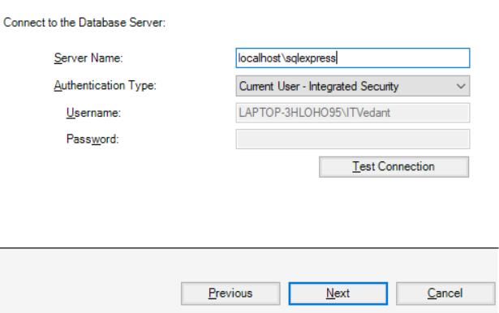

1. Keep the Database Name as Report Server and select Next.

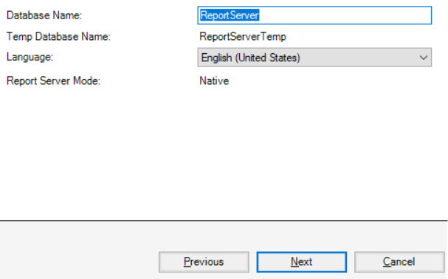

1. Select Next.
2. Again, select Next.
3. After configuration, select Finish.

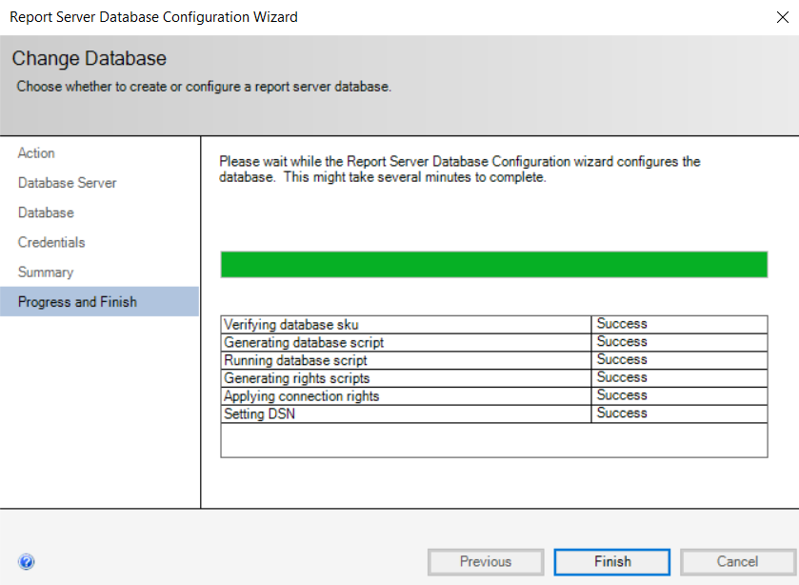

1. Now to access Web Portal, Go to Web Portal URL and click on the URL.
2. If the Web Portal is not accessible, try changing the port number by select Web Service URL and change the port number from 80 to 8082.